**EXPERIMENT 3.2**

**NAME: Yash Gupta UID: 20BCS5009**

**SECTION: 709 A Sub: Software Engineering**

**Aim:**

1. Design a structure chart for a student registration process who is taking admission in a college/university.
2. Design a structure chart for a ticket vending machine at a metro station.

**Requirement Analysis:**

* Software Requirement:

Digram.net

Google Chrome

* Hardware Requirement:

Computer

Internet

1. Design a structure chart for a student registration process who is taking admission in a college/university.

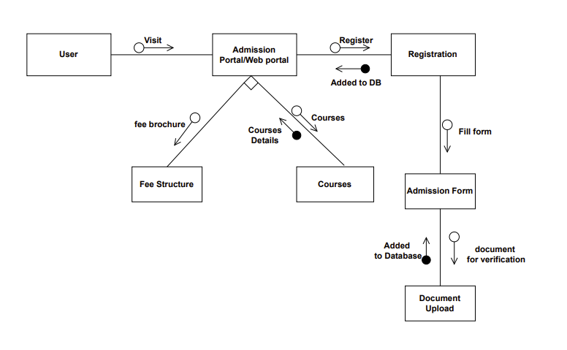

1. Design a structure chart for a ticket vending machine at a metro station.

